Soundsystem oude Luxor Theater Rotterdam

cluster 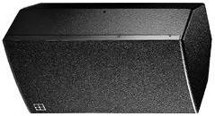ci60
ci90

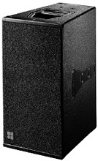 Q7 Q7
Q10 Q10
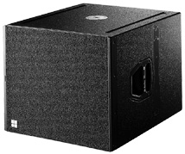 Qsub 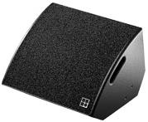 Infill 2x max12

Delay 2x Ci60

All speakers on E-pac Amps 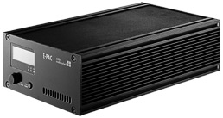 Except Subs on D12 Amps 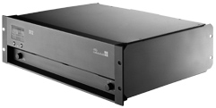

Monitors Eff.
4x D&B Max 15 2x EQ White 4828 31-bands
1x Limiter DBX 1046
Div. M2000 tc electr.
2x SM58 Shure mic.
2x DI countryman type 85 ASL headsets and beltpacks (NO WIRELESS)
1x MD sony
